Memo
To: | Dr. Cranford
From: | NC Health Department

cc:
Date: | March 17, 2021
Re: | Proposal to Setup Vaccination Distribution
Patients that meet the criteria for vaccinations should be made aware of the appointment line. However, with limited supply of vaccines the amount of appointments can vary from week to week. All the patients who meet the requirements of the phases must be made aware of the vaccine. The vaccine is given on a voluntary basis, and is approved under Federal Drug Administration (FDA) for emergency use only.
The NC Health Department has stated that the vaccines distributed are effective, safe, and tested. Many patients worry about the safety of the vaccine due to the small testing time during the creation of the vaccine. Patients can be directed to the CDC website information on previous testing conducted before the emergency release of the vaccine. “COVID-19 vaccines will help us gain control of our lives and get back to the people and places we love” (NCDHHS).
“Your best shot at stopping the COVID-19” is thru vaccination (WakeMed). Setting up the process to distribute the vaccines is vital to our healthcare commitment to our patients and community. As healthcare providers we strive to help our patients retain the best care possible. Currently, there are 3 phases all with different criteria’s that are met before an appointment is made. There are 2 groups, 1st priority group and the 2nd subgroups category. Timeline for implementation of phase 1 starts January 2021 until May 2021, phase 2 is from late spring/ early summer 2021, and phase 3 is from late summer until fall/winter 2021.

- Define Phase I, II, and III criteria
- Contact Patients Meeting Criteria
- Setup Access to Appointment Line
- What to Expect After Vaccination

Timeline for Vaccination Distribution
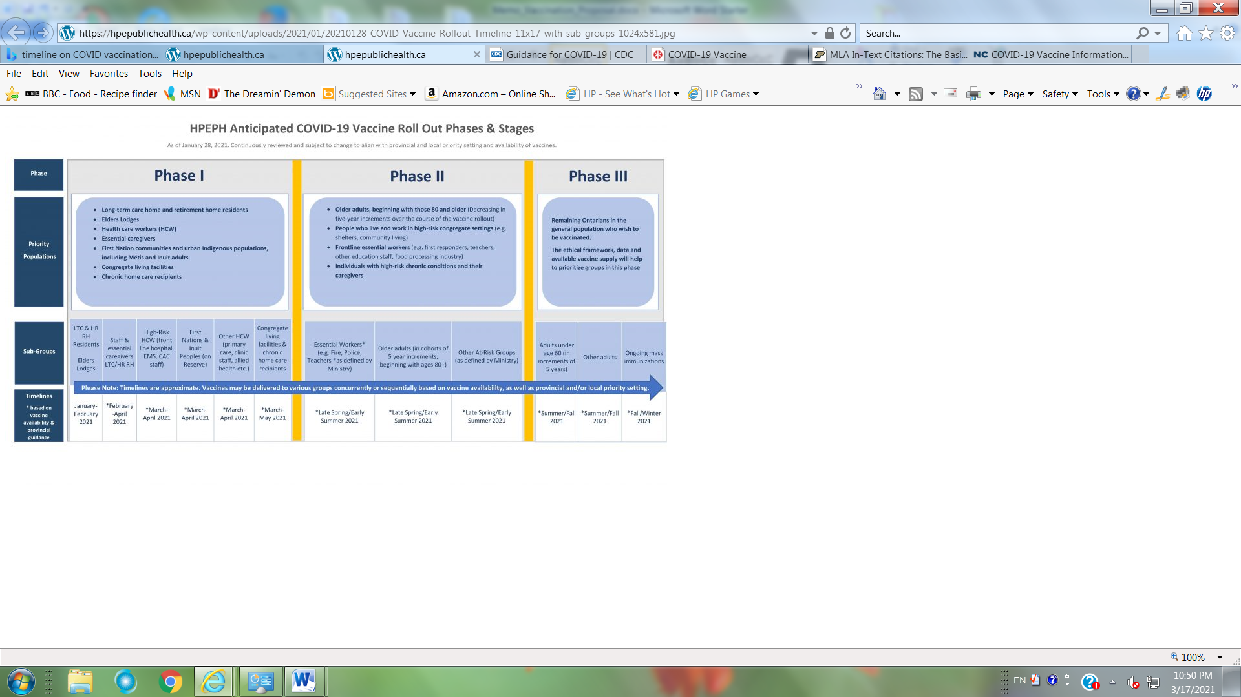

References

COVID-19 Vaccines – Hastings Prince Edward Public health. www.hpepublichealth.ca January 28th, 2021.

COVID-19 Vaccine Information. www.WakeMed.org/patients-and-vistors/covid-19-information/covid19-vaccine March 2021.

North Carolina Department of Human and Health Services (NCDHHS). www.covid19.ncdhhs.gov/vaccines. March 2021.

